Unit-III: GAME THEORY

INTRODUCTION
In real-life, we can see a great variety of competitive situations. Game theory provides tools for analysing situations in which parties, called players, make decisions that are interdependent. This interdependence causes each player to consider the other player’s possible decisions, or strategies, in formulating strategy. A solution to a game describes the optimal decisions of the players, who may have similar, opposed, or mixed interests, and the outcomes that may result from these decisions. So, one can say that it is a type of decision theory. Game theory was originally developed by John von Neumann (called the father of game theory) and his colleague Oskar Morgenstern to solve problems in economics.
In this chapter, first we define some basic terms used in game theory then we shall discuss two-person zero-sum-games (also known as rectangular games), games with saddle point in which we study minimax and maximin criterion. Also, we shall explain rules of dominance which are used to reduce the size of the payoff matrix and discuss solution methods for game without saddle point namely algebraic method, graphical method and linear programming method.
Objectives. The objective of these contents is to get familiar reader with game theory. After studying this chapter, reader should be able to describe the following concepts like:
- Minimax and Maximin Principle
- Pure Strategies: Game with Saddle Points
- The Rule of Dominance
- Mixed Strategies: Game without Saddle Points

SOME BASIC DEFINITIONS
Game: A competitive situation is called a game if it has the following properties
- There are finite numbers of participants called players.
- Each player has finite number of strategies available to him.
- Every game result in an outcome.
Player: Each participant of a game is called a player.
Number of players: If a game involves any two payers, it is called a two-person game. However, if the number of players is more than two, the game is known as n-person game.
Payoff: A quantitative measure of satisfaction, a person gets at the end of each play, is called a payoff.
Play: A play is said to occur when each player chooses one of his activities.
Strategy: The strategy for a payer is the list of al possible actions or moves available to him. Generally, two types of strategies are employed by players in a game.
- Pure strategy: It is a decision rule which is always used by the player to select any one particular course of action. The objective of the payer is to maximize gains or minimize losses.
- Mixed strategy: When the players use a combination of strategies and each player always keep guessing as to which course of action is to be selected by the other on a particular occasion, then this is known as mixed strategy. Thus, the mixed strategy is a selection among pure strategies with fixed probabilities.

Zero-sum game. A game in which the algebraic sum of the outcomes for all the participants equals zero for very possible combination of strategies, is called a zero-sum game.
A game which is not zero-sum is called a non-zero-sum game.
Optimal strategy. A course of action or play which puts the player in the most preferred position, irrespective of the strategy of his competitors, is called optimal strategy.
Value of the game. The expected payoff when the players follow their optimal strategy is called the value of the game.

TWO-PERSON ZERO-SUM GAME
A game with only two-persons is said to be two-person zero-sum game if the gain of one player is equal to the loss of the other so that total sum is zero.
Payoff Matrix: In a two-person game, the payoffs in terms of gains or losses, when players select their particular strategies can be represented in the form of a matrix, called the payoff matrix of the player. If the game is zero-sum, the gain of one player is equal to the loss of the other and vice-versa. So, one player’s payoff table would contain the same amounts I payoff table of the other payer with the sign changed. If the player A has strategies A1, A2, …, An and the player B has strategies B1, B2, …, Bn and if

aij
represent the payoffs that the player A gains from player B when player A chooses strategy i, and player

B chooses strategy j then payoff matrix for player A is given by
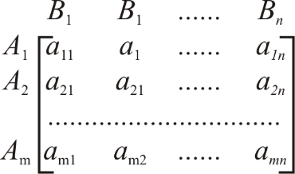
Player B’s strategies

Player A’s strategies

Basic Assumptions of the Game:
Rules of the game are given as follows:
  - Each player has available to him a finite number of possible courses of action. The list may not be the same for each player.
  - Players act rationally and intelligently.
  - The decisions of both the payers are made individually, prior to the play, with no communication between them.
  - One player attempts to maximize gains and the other attempts to minimize losses.
  - The players simultaneously select their respective courses of action.
  - The payoff is fixed and determined in advance.
  - List of strategies of each player and the amount of gain or loss on an individual’s choice of strategy is known to each player in advance.

PURE STRATEGIES: GAMES WITH SADDLE POINT
Consider the payoff matrix of a game which represents payoff of player A. Now, the objective of the study is to know how these players must select their respective strategies so that they may optimize their payoff. Such a decision-making criterion is referred to as the minimax-maximin principle.
For payer A, the minimum value in each row represents the least gain to him if he chooses his particular strategy. He will then select the strategy that gives the largest gain among the row minimum values. This choice of player A is called the maximin principle and the corresponding gain is called the maximin value of the game denoted by v.
For player B, who is assumed to be loser, the maximum value in each column represents the maximum loss to value in each column represents the maximum loss to him if he chooses his particular strategy. He will then select the strategy that gives minimum loss among the column maximum values. This choice of player B is called the minimax principle and the corresponding loss is called the minimax value of the game, denoted by v .
Saddle point. A saddle point of a payoff matrix is that position in the payoff matrix where maximum of row minima coincides with the minimum of the column maxima. The saddle point need not be unique.
Value of the game. The amount of payoff at the saddle point is called the value of the game, denoted by v.
Fair game. A game is said to be fair if v = 0 = v .
Strictly determinable game. A game is said to be strictly determinable if v = v = v .

Procedure to Determine Saddle Point
      - Select the minimum element in each row and enclose it in a rectangle box.
      - Select the maximum element in each column and enclose it in a circle.
      - Find the element which is enclosed by the rectangle as well as the circle such element is the value of the game and that position is a saddle point.
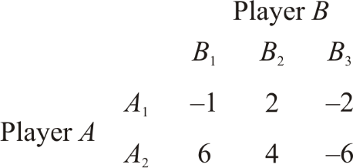
Example. For the game with payoff matrix:
Determine the optimal strategies for players A and B. Also determine the value of game.
Is this game (i) fair? (ii) strictly determinable?
Solution. Select the row minimum and enclose it in a rectangle. Then select the column maximum and enclose it in a circle.

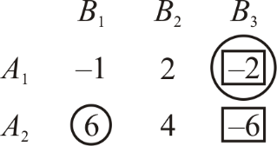
Saddle point is ( A₁, B₃ ) . Value of game = –2
Optimal strategy for A is A1 and for B is B3.
The game is strictly determinable. Since value of game is not zero, the game is not fair.
Example. Determine which of the following two-person zero-sum games are strictly determinable and fair. Give optimum strategies for each player in case of strictly determinable games:
Solution. (a) Payoff matrix for player A is:
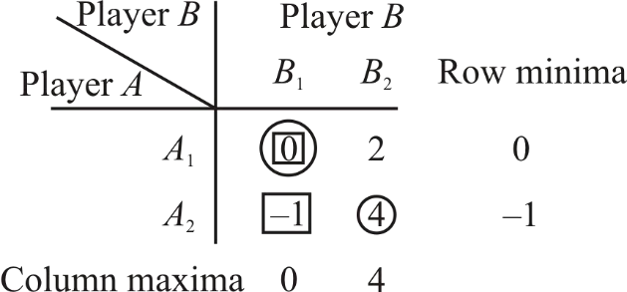
v (maximin value) = 0
v (minmax value) = 0
Since v = −1, v = 1, game is not strictly determinable.
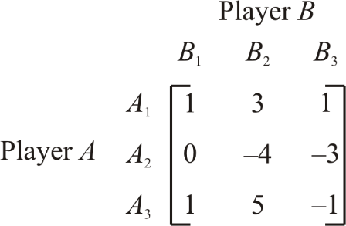
Example. Solve the game hide payoff matrix is given by
Solution. Select the row minimum and enclose it in a rectangle select the column maximum and enclose it in a circle.

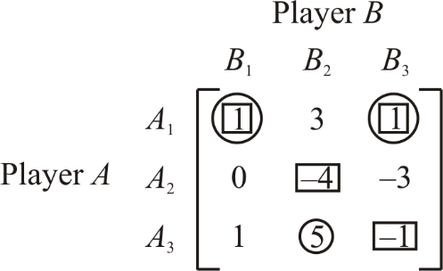
We observe that there exist two saddle points at positions (1, 1) and (1, 3). Thus, the solution of the game is given by
- the optimum strategy for player A is A1.
- the optimum strategies for player B are B1 and B3.
- the value of game is 1 for A and B. Since v ≠ 0 , the game is not fair.
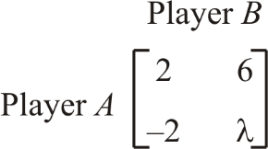
Example. Consider the game G with the following payoff matrix:
- Show that G is strictly determinable, whatever λ may be
- Determine the value of G.
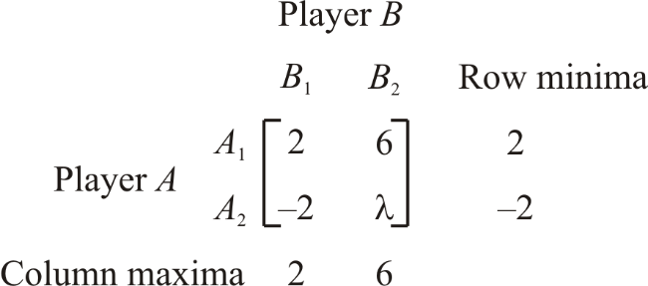
Solution. First, ignoring the value of λ , we determine the maximin and minimax values of the payoff matrix, as shown below:
Example. For what value of λ , the game with following payoff matrix is strictly determinable?
 | B1 | B2 | B3
A1 | λ | 6 | 2
A2 | –1 | λ | –7
A3 | –2 | 4 | λ

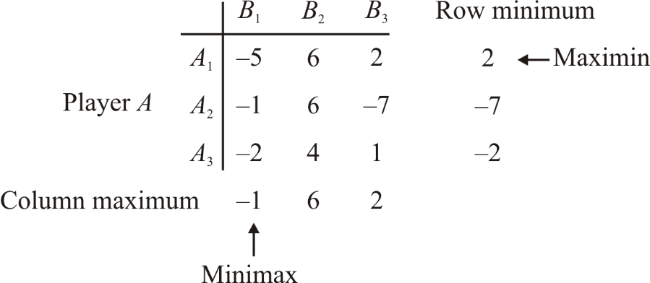
Solution. Ignoring the value of λ , we determine the maximin and minimax values of the payoff matrix, as shown below

Here maximin value = 2, minimax value = –1. The value of game lies between –1 and 2.
For strictly determinable game, since maximin value equals minimax value, we must have
Exercises. Solve the games whose payoff matrices are given below.

−1 ≤ λ ≤ 2 .

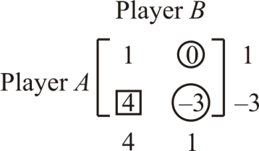
1.
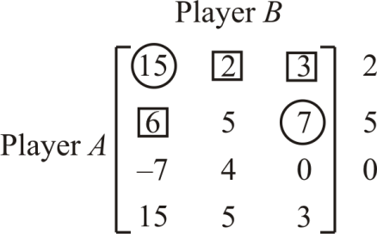
Answer. v = 1

2.
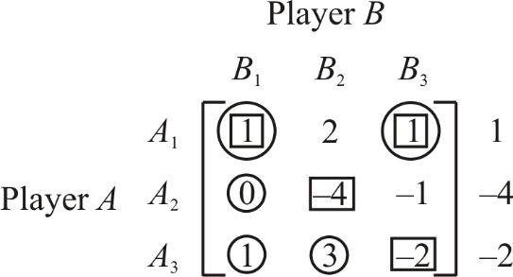
Answer. ( A₂, B₂ ), v = 5

3.
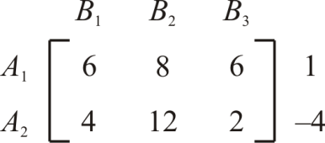
Answer. ( A₁, B₁ ), ( A₁, B₃ ), v =1 for A.

4.
Answer. ( A₁, B₁ ), ( A₁, B₂ ), v = 6

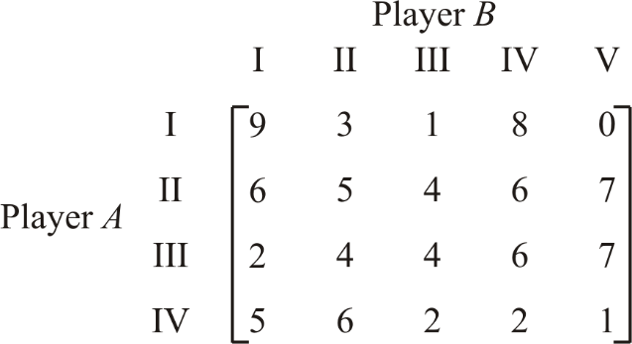
5.
Answer. (II, III), v = 4
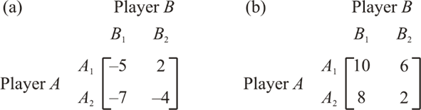
6 Determine which of the following two-person zero-sum games are strictly determinable and fair? Give the optimum strategies for each player in case of strictly determinable games.
Answer. (a) ( A₁, B₁ ), v = −5 , not fair(b) ( A₁, B₂ ) , value = 6, not fair.

PRINCIPLE OF DOMINANCE
The principle of dominance is used to reduce the size of a games payoff matrix by eliminating a course of action which is so inferior to another as never to be used. Such a course of action is said to be dominated by the other. It is applicable to both pure and mixed strategy problems. However, this rule is especially useful for the evaluation of two-person zero-sum games where a saddle point does not exist.
In general, the following rules of dominance are used to reduce the size of payoff matrix.
Rule 1. If all the elements in a column are greater than or equal to the corresponding elements in another column, then that column is dominated and can be deleted from the matrix.
Rule 2. If all the elements in a row are less than or equal to the corresponding elements in another row, then that row is dominated and can be deleted from the matrix.
Rule 3. If all the elements in a column are greater than or equal to the average of the corresponding elements of two or more other columns, then that column can be deleted.
Rule 4. If all the elements in a row are less than or equal to the average of the corresponding elements of two or more other rows, then it can be deleted.
Example. Reduce the following game to 2 × 2 game using principle of dominance.

Player B
 |  | I | II | III | IV | V | VI
 | I | 4 | 2 | 0 | 2 | 1 | 1
 | II | 4 | 3 | 1 | 3 | 2 | 2
Player A | III | 4 | 3 | 7 | –5 | 1 | 2
 | IV | 4 | 3 | 4 | –1 | 2 | 2
 | V | 4 | 3 | 3 | –2 | 2 | 2

Solution. Column I, II and IV are dominated by column V, so columns I, II and VI are deleted. The reduced matrix is
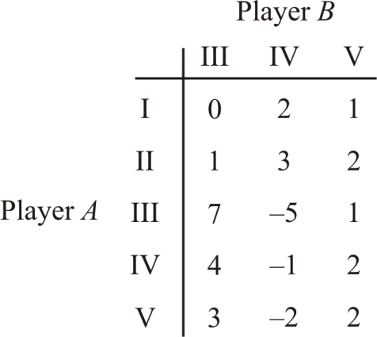
Now row I is dominated by row 2 and row 5 is dominated by row 4. Hence deleting rows I and V, we have
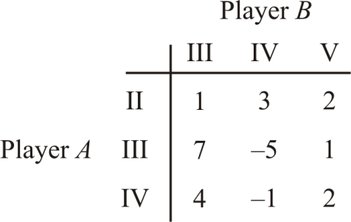
Now none of single row (or column) dominates another row (or column. However, column V is dominated by the average of columns III and IV. Hence deleting column V, we have
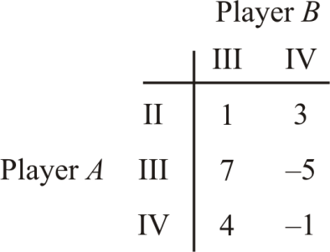
Now average of row II and row III gives the row (4, –1) which dominates the row IV. Hence deleting row IV, we have
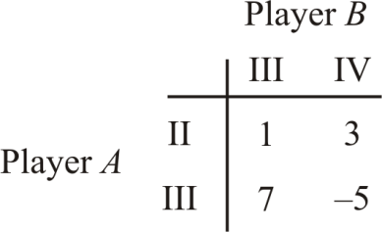
Example. Reduce the following game into 2 × 2 game using the rules of dominance.
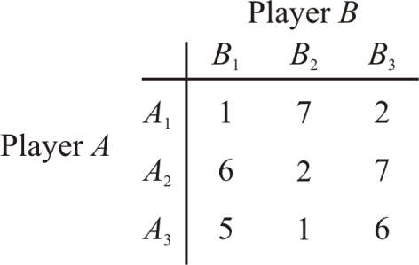

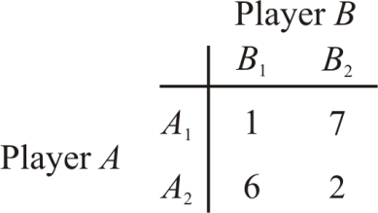
Solution. First, we delete the column 3 as all the elements of this column are greater than that of first column after that we delete 3rd row as all the elements of row 3 are less than the corresponding elements of row 2. Hence the reduced matrix is

MIXED STRATEGIES: GAMES WITHOUT SADDLE POINT
Pure strategies are available as optimal strategies only for those games which have a saddle point. For games which do not have a saddle point can be solved by applying the concept of mixed strategies. Her, we study algebraic, graphical and linear programming method to solve mixed strategies games.

Algebraic Method
Consider the two-person zero-sum game with the following payoff matrix:
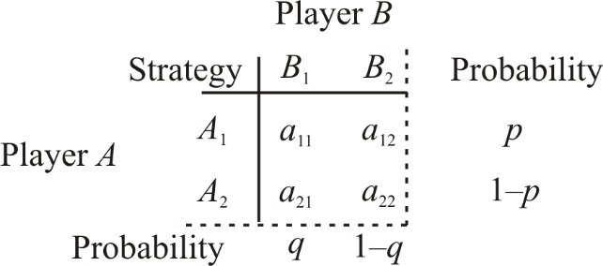
If this game is to have no saddle point, the two largest elements of the matrix must constitute one of the diagonals. We have assumed this and therefore both players use mixed strategies. Our task is to determine the probabilities with which both players choose their course of action.

In this game, let player A play the strategies
A1 and
A₂ with respective probabilities p and 1 – p

and let player B play his strategies B1 and B2 with respective probabilities q and 1 – q. The expected payoffs to player A when B plays any one of his strategies B1 or B2 throughout the game, are given by

B’s Strategy | A’s Strategy
B1 | a₁₁ p + a₂₁ (1− p)
B2 | a₁₂ p + a₂₂ (1− p)
Now in order that player A is unaffected with whatever choice of strategies B makes, we must have
a₁₁ p + a₂₁ (1− p) = a₁₂ p + a₂₂ (1− p)
⇒ (a₁₁ − a₁₂ ) p + (a₂₂ − a₂₁ ) p = a₂₂ − a₂₁

⇒ p =
a22 − a21

(a11 − a12 ) + (a22 − a21 )

and
1− p =
a11 − a12

(a11 − a12 ) + (a22 − a21 )

similarly, by equating the expected payoffs of the player B, for whatever choice of strategies player A
makes, we have
a₁₁q + a₁₂ (1− q) = a₂₁q + a₂₂ (1− q)
This implies
⎣⎡(a₁₁ − a₂₂ ) + (a₂₂ − a₁₂ )⎤⎦ q = a₂₂ − a₁₂

So q =
a22 − a12
(a11 − a21 ) + (a22 − a12 )
and 1− q = (a11 − a21 )
(a11 − a21 ) + (a22 − a12 )

The value of game, v is found by substituting the value of p in one of the expressions for the expected gains of A so that
v = a₁₁ p + a₂₁ (1− p)

= a11 (a22 − a21 )
(a11 − a12 ) + (a22 − a21 )
= a11a22 − a12a21
(a11 − a12 ) + (a22 − a21 )
+ a21 (a11 − a12 )
(a11 − a12 ) + (a22 − a21 )

Hence the solution of the game is

A plays ( p,1− p) where
p = a22 − a21
(a11 − a12 ) + (a22 − a21 )

B plays (q,1− q) where q =
a22 − a12

(a11 − a12 ) + (a22 − a21 )

and value of game, v =
a11a22 − a12a21 .
(a11 − a21 ) + (a22 − a12 )

Example. Solve the following game:
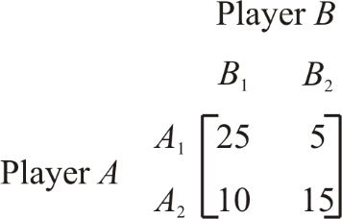
Solution. Here maximin value = 10 and minimax value = 15. So, game has no saddle point.
Let the player A play his first strategy A1 with probability p, then he would play his second strategy A2

with probability (1− p) . Then expected gain of A is B selects B1, is equal to 25 p +10(1− p)
p and the expected gain of A if B selects strategy B2, is equal to 5 p +15(1− p) i.e. 15 – 10 p.
i.e. 10 + 15

Now in order that the player A may be unaffected with whatever choice B makes, the optimal plan for the player A should be such that the expected payoffs for each of B’s strategies should be equal is
10 + 15 p = 15 – 10 p

∴ p =
5 = 1 and 1− p = 1− 1 = 4

25 5 5 5

Hence, the player A would play his first strategy A1 with probability 1
5

and second strategy A2 with

probability 4 .
5
Similarly, if the player B selects strategies B1 and B2 with probabilities q and 1 – q respectively, then the expected loss to B when A adopts the strategy A1, is 25 q + 5(1 – q) and the expected loss to B when the player A adopts the strategy A2, is 10 q + 15 (1 – q). By equating the expected losses of player B, for whatever choice of strategies player A makes, we have
25q + 5(1− q) = 10q +15(1− q)
⇒ 20q + 5 =15 − 5q

⇒ q = 10 = 2
25 5
and 1− q = 3
5

Hence the player B would play his strategies B1 and B2 with probabilities 2
5
and 3
5
respectively.

Value of the game = expected payoff to player A
= 25 p +10(1− p)
= 25× 1 +10× 4 = 13.
5 5
Example. For the following game:
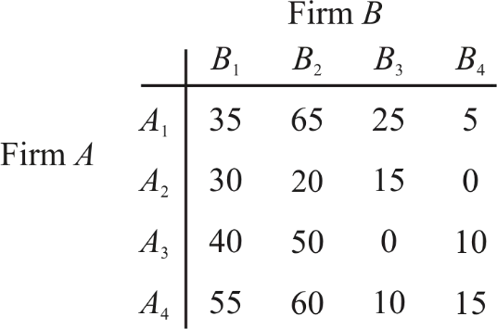
Determine the optimal strategies for each firm and value of the game.
Solution. Since maximin value = 10 and minimax value = 15, there is no saddle point.
We apply rules of dominance to reduce the size of payoff matrix. Since each element of second row is less than the corresponding elements of first row, second row is dominated by first row. So, deleting the second row, the reduced matrix becomes

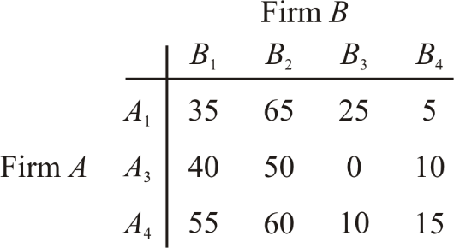
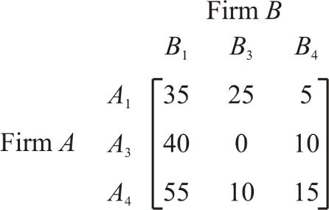
In the reduced matrix, each element of second column is more than the corresponding elements in first column, so second column is dominated by first column. Thus after deleting the second column, the reduced matrix becomes
Further second row is dominated by third row, so we delete second row to get reduced matrix as
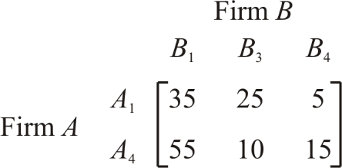
Now column one is dominated by column two. So, we delete column one and reduced matrix becomes
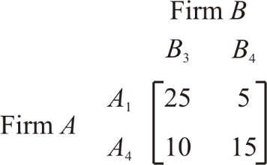
Now we solve the game by algebraic method in the same manner as we did in example 9.6.1.1. Thus, firm

A would select strategy A1 with probability 1
5
and strategy A4 with probability 4
5
and firm B would select

strategy B3 with probability 2
5
and strategy B4 with probability 3
5
and Value of game =

25 p +10(1− p) = 25⋅ 1 +10⋅ 4 = 5 + 8 = 13.
5 5
Example. In a game of matching coins with two players, suppose one player wins Rs. 2 when there are two heads and wins nothing when there are two tails, and losses Re. 1 when there are one head and one tail. Determine the payoff matrix, the best strategies for each player and the value of the game.
Solution. Let the two players be A and B. Then the payoff matrix for player A is

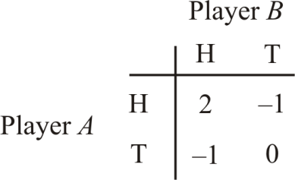
Here maximin value (v) = −1; minimax value (v ) = 2 .
Since v ≠ v , given game has no saddle point. Let the player A plays H with probability p and T with

probability 1 – p. Then A’s expected gains when B plays H and T respectively, are
− p + 0(1− p) .
For best strategy of A, we have
2 p + (−1)(1− p) = − p .
2 p + (−1)(1− p) and

so that

1 and 3
4 4
p = 1 and 1− p = 3 . Therefore, best strategy for player A is to play H and T with probabilities
4 4
respectively.

For player B, let the probability of the choice of H be q and that of T be 1 – q. For best strategy of
B, we have

2q +(−1)(1− q) = (−1)q + 0(1− q)
so that q = 1 and 1− q = 3 .
4 4

Hence player B should play H and T with probabilities 1 and 3
4 4

respectively.

Value of game = 2 p + (−1)(1− p) = − 1
4

for player A.

9.6.1.4 Exercises. Solve the following games without saddle points.

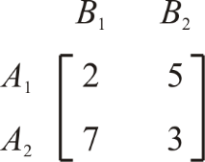
1.
Answer. ⎛ 4 , 3 ⎞
⎜ 7 7 ⎟
⎝ ⎠

for player A, ⎛ 2 , 5 ⎞
⎝ ⎠
⎜ 7 7 ⎟

for player B and Value of game = 0.

- In a game of matching coins with two players, suppose A wins one unit of value, when there are

two heads, wins nothing when there are two tails and loses 1
2
unit of value when there are one head and

one tail. Determine the payoff matrix, the best strategies for each player and the value of game to A.

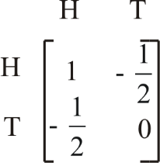
Answer. Payoff matrix for A is
Optimal strategies for two players are ⎛ 1 , 3 ⎞, ⎛ 1 , 3 ⎞
⎜ 4 4 ⎟ ⎜ ⎟44
⎝ ⎠ ⎝ ⎠

and value of the game is − 1 .
8

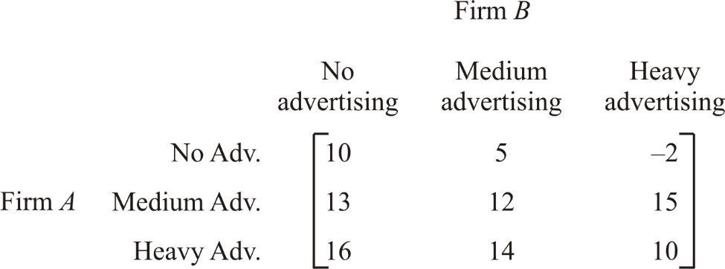
- The firms are competing for businesses under the conditions so that one firm’s gain is another firm’s loss. Firm A’s payoff matrix is given below:
Suggest the optimum strategies for the firms.
⎛ 4 3 ⎞ ⎛ 5 2 ⎞ 90

Answer.
⎜ 0, , ⎟, ⎜ 0, , ⎟, v = .

⎝ 7 7 ⎠ ⎝
7 7 ⎠ 7

Graphical method
The graphical method is useful for solving two person–zero–sum–game. A Game having saddle point can be easily solved, so, we consider games without saddle point, where the payoff matrix is of size 2× n or m × 2.
Optimal strategies for both the players assign no–zero probabilities to the same number of pure games. Therefore, if one player has only two strategies, the other will also use the same number of strategies. Hence, this method is useful in finding out which of the two strategies can be use. Consider the following 2 × n payoff matrix of a game without saddle point.

Player A | 𝐵₁ | 𝐵₂ | 𝐵₃ | Probability
𝐴1 | 𝑎11 | 𝑎12 | 𝑎13 | p1
A2  Probability | 𝑎21  𝑞₁ | 𝑎22  𝑞₂ | 𝑎23  𝑞₃ | p2
To solve this game, we draw two vertical lines at unit distance, for representing p1=0 and p2=0 where p= (p1, p2) is the strategy of A and q= (q1, q2, …, qn) is the strategy of B.

We now draw n line segments joining the points (0, a2j) and (1, a1j), j= 1, 2, …, n but excluding the end points. The lower envelope of these lines gives the minimum expected gain of A as a function of p1. The highest point o of this lower boundary of these lines will give maximum of the minimum gain of A, i.e. maximin of A.
Now, the two strategies of player B corresponding to those lines which pass through the maximum point can be determined. It helps in reducing the size of the game to (2 × 2), which can be easily solved by any of the methods discussed earlier.
Remark: The (m×2) games are also treated in the same way except the upper boundary of the straight lines corresponding to B’s expected payoff will give the maximum expected payoff to player B and the lower point on this boundary will then give the minimum expected payoff (minimax value) and the optimum value of probability 𝑞₁ and 𝑞₂.
9.6.2.1. Example. Use graphical method in solving the following game and find the value of the game Solve the following game:
 |  | Player B
 | B1 | B2 | B3 | B4
Player A 𝐴₁ | 0 | 5 | -2 | 3
𝐴₂ | 2 | 3 | 4 | 1

Solution. Since maximin 𝑎_{𝑖𝑗} = 3 < 𝑚𝑖𝑛𝑖𝑚𝑎𝑥 𝑎_{𝑖𝑗} = 4, the game is to be solved by mixed strategies. We therefore use the graphical method to reduce this to a 2× 2 by game as follows:

5 |  | B2 | 5
4 |  |  | 4
3 |  | B4 | 3
2 |  |  | 2
1 | B1 |  | 1
0 |  |  | 0
-1 |  | B3 | -1
-2 |  |  | -2
-3 |  |  | -3

We join the points 0, 5, -2 and 3 on the left line given by 𝑝₁= 0 to the points 2, 3, 4 and 1 on the right line given by 𝑝₂=0 respectively. Clearly the highest point of the lower envelop determines the strategies B1 and B4.
So, the reduced game is:
Player B B1 B4
Player A A1 0 3
A2 2 1
Solving this game, we get
𝑝₁* =1/4, 𝑝₂* =3/4; 𝑞₁* =1/2, 𝑞₄*=1/2
Hence the required solution is
Note: An m x n game is solvable if it has a saddle point but if it has no saddle point, it cannot be solved by graphical method unless it is reducible to the form m x 2 or 2 x n game by the dominance principle.

Linear Programming Method
The two person – zero – sum - game can also be solved by linear programming. The major advantages of using the programming technique is to solve mixed-strategy games of larger dimension payoff matrix.
To illustrate the transformation of the game problem to a linear programming problem, consider a payoff matrix of size m × n. Let 𝑎_{𝑖𝑗} be the element in the ith row and jth column of game payoff matrix, and letting the probabilities of m strategies ( i = 1, 2, 3, ... , m) for player A, for each of player B’s strategies will be

𝑚
V = ∑
𝑖=1
𝑝_{𝑖}. 𝑎_{𝑖𝑗}, j = 1, 2, ..., n

The aim of player A is to select a set of strategies with probability 𝑝₁, the value of the game to the played A for all strategies by the player B must be at least equal to V. Thus, to miximize the minimum expected gains, it is necessary that
𝑎₁₁𝑝₁ + 𝑎₁₂𝑝₂ + ⋯ + 𝑎_{𝑚1}𝑝_{𝑚} ≥ 𝑉
𝑎₂₁𝑝₁ + 𝑎₂₂𝑝₂ + ⋯ + 𝑎_{𝑚2} ≥ 𝑉
.
.
.
𝑎_{1𝑛}𝑝₁ + 𝑎_{2𝑛}𝑝₂ + ⋯ + 𝑎_{𝑚𝑛}𝑝_{𝑚} ≥ 𝑉
𝑝₁ + 𝑝₂ + ⋯ + 𝑝_{𝑚} = 1; 𝑝_{𝑖} ≥ 0 for all i
Dividing both sides of the m inequalities of the and equation by V the division is valid as long as V > 0. In case V < 0, The direction of inequality constraints must be reversed. But if V = 0, division would be meaningless. In this case a constraint can be added to all entries of the matrix ensuring that the value of

the game (V) for the revised matrix becomes more than zero. After optimal solution is obtained for the

value of the game is obtained by subtracting the same constant value. Let 𝑝𝑖⁄𝑉
= 𝑥_{𝑖}, (≥ 0). Then we get,

𝑎11

𝑎12
.
.
.

𝑃1

𝑝2
≥ 1

≥ 1
𝑃₁ |  | 𝑝₂ |  | 𝑝_{𝑚}
𝑉  𝑃₁ | + 𝑝₂₁ | 𝑉  𝑝₂ | + ⋯ + 𝑎_{𝑚1} | 𝑉  𝑝_{𝑚}
𝑉 | + 𝑝₂₂ | 𝑉 | + ⋯ + 𝑎_{𝑚2} | 𝑉

𝑝𝑚

𝑎_{1𝑛} 𝑉 + 𝑝_{2𝑛} 𝑉 + ⋯ + 𝑎_{𝑚𝑛} 𝑉 ≥ 1
𝑝1 + 𝑝2 + ⋯ + 𝑝𝑚=1
𝑉 𝑉 𝑉
Since, the objective of player A is to maximize the value of the game, V which is equivalent to minimize
¹ , the resulting linear programming problem can be stated as
𝑉
𝑎₁₁𝑥₁ + 𝑎₁₂𝑥₂ + ⋯ + 𝑎_{𝑚1}𝑥_{𝑚} ≥ 𝑉
𝑎₂₁𝑥₁ + 𝑎₂₂𝑥₂ + ⋯ + 𝑎_{𝑚2}𝑥_{𝑚} ≥ 𝑉
.
.
.
𝑎_{1𝑛}𝑥₁ + 𝑎_{2𝑛}𝑥₂ + ⋯ + 𝑎_{𝑚𝑛}𝑥_{𝑚} ≥ 𝑉

And 𝑥₁
, 𝑥₂
, … , 𝑥_{𝑚}
≥ 0, 𝑥_{𝑖}
= 𝑝𝑖 ; i = 1, 2, ..., m
𝑉

Similarly, Player B has a similar problem with the inequalities of the constraints reversed, i.e., minimize the expected loss. Since minimizing of V is equivalent to maximizing ¹, therefore, the resulting
𝑉
programming problem can be stated as:

Maximize

1
𝑍_{𝑞} (= 𝑉) = 𝑦₁ + 𝑦₂ + ⋯ + 𝑦_{𝑛}

Subjected to the constraints

𝑎₁₁𝑦₁ + 𝑎₁₂𝑦₂ + ⋯ + 𝑎_{1𝑛}𝑦_{𝑛} ≤ 1
𝑎₂₁𝑦₁ + 𝑎₂₂𝑦 + ⋯ + 𝑎_{2𝑛}𝑦_{𝑛} ≤ 1
.
.
.
𝑎_{𝑚1}𝑦₁ + 𝑎_{𝑚2}𝑦₂ + ⋯ + 𝑎_{𝑚𝑛}𝑦_{𝑛} ≤ 1

And 𝑦₁, 𝑦₂, … , 𝑦_{𝑛} ≥ 0

Where,𝑦_{𝑗}
= 𝑞𝑗 ≥ 0 ; i = 1, 2, ..., n
𝑉

It may be noted that the LP problem for the player B is the dual of LP problem for plater A and vice- versa. Therefore, solution of the dual problem can be obtained from the primal simplex table. Since both the players 𝑍_{𝑝} = 𝑍_{𝑞}, the expected gain to player A in the game will be exactly equal to expected payoff to player B.
Remark: Linear programming technique require all variables to be non-negative and therefore to derive a non – negative value V of the game, the data to the problem, i.e., 𝑎_{𝑖𝑗} in the payoff table should be non – negative. If there are some negative elements in the payoff table, a constant to every elements of the payoff table must be added so as to make the smallest element zero; the solution to this new game give an optimal mixed strategy for the new game. The value of the original game then equals to the value of the new game minus the constant.
Example. For the following payoff matrix, transform the zero-sum game into an equivalent linear programming problem and solve it by using simplex method.
Player B

Player A | B1 B2 B3
A1 A2 A3 | 1 -1 3  3 5 -3  6 2 -2
Solution: The first step is to find out the saddle point (if any) in the payoff matrix as shown below
Player B
Player A B1 B2 B3 Row minimum

A1 1
A2 3
A3 6
-1
5 -3
3
2 -2
-1 ← Maximin
-3
-2

Column maximum 6 5 ← Minimax
3
The given game payoff matrix does not have a saddle point. Since, the maximin value is -1, therefore, it is possible that the value of game (V) may be negative or zero because -1< 𝑉 < 1. Thus, a constant which is at least equal to the negative of maximin value, i.e., more than -1 is added to all elements of the payoff matrix. Thus, adding a constant number 4 to all the elements of the payoff matrix, the payoff matrix becomes:
Player B
Player A B1 B2 B3 Probability A1 5 3 7 𝑝₁
A2 7 9 1 𝑝₂
A3 10 6 2 𝑝₃
Probability 𝑞₁ 𝑞₂ 𝑞₃

Let 𝑝𝑖 (𝑖 = 1,2,3) and 𝑞𝑗 (𝑗 = 1,2,3) be the probabilities of selecting strategies
𝐴_{𝑖}(𝑖 = 1,2,3) and 𝐵_{𝑗} (𝑗 = 1,2,3) by players A and B, respectively. The expected gain for player A will be as follows:
5𝑝₁ + 7𝑝₂ + 10𝑝₃ ≥ 𝑉 (if B uses strategy B1)
3𝑝₁ + 9𝑝₂ + 6𝑝₃ ≥ 𝑉 (if B uses strategy B2)
7𝑝₁ + 𝑝₂ + 2𝑝₃ ≥ 𝑉 (if B uses strategy B3)
𝑝₁ + 𝑝₂ + 𝑝₃ = 1
and 𝑝₁, 𝑝₂, 𝑝₃ ≥ 0
Dividing each inequality and equality by V, we get, 5^{𝑝1} + 7 𝑝2 + 10 𝑝3 ≥ 1
𝑉 𝑉 𝑉
3^{𝑝1} + 9 𝑝2 + 6 𝑝3 ≥ 1
𝑉 𝑉 𝑉
7^{𝑝1} + 𝑝2 + 2 𝑝3 ≥ 1

𝑉 𝑉 𝑉

𝑝₁

𝑉

𝑝₂
+
𝑉

𝑝₃ 1
+ =
𝑉 𝑉

In order to simplify, we define new variables:
𝑥₁ = 𝑝₁⁄𝑉 , 𝑥₂ = 𝑝₂⁄𝑉
The problem for player A, therefore becomes,

𝑎𝑛𝑑 𝑥₃ = 𝑝₃⁄𝑉

Minimize 𝑍_{𝑝} (=1/V) =𝑥₁ + 𝑥₂ + 𝑥₃ subject to the constraints
5𝑥₁ + 7𝑥₂ + 10𝑥₃ ≥ 1
3𝑥₁ + 9𝑥₂ + 6𝑥₃ ≥ 1
7𝑥₁ + 𝑥₂ + 2𝑥₃ ≥ 1
and 𝑥₁, 𝑥₂, 𝑥₃ ≥ 0
player B’s objective is to minimize his expected losses which can be reduced to minimizing the value of the game V. Hence, the problem of player B can be expressed as follows:
Minimize 𝑍_{𝑞} (=1/V) =𝑦₁ + 𝑦₂ + 𝑦₃
subject to the constraints

and 𝑦₁, 𝑦₂, 𝑦₃ ≥ 0
where 𝑦₁ = 𝑞₁⁄𝑉 , 𝑦₂ = 𝑞₂⁄𝑉
5𝑦₁ + 7𝑦₂ + 10𝑦₃ ≤ 1
3𝑦₁ + 9𝑦₂ + 6𝑦₃ ≤ 1
7𝑦₁ + 𝑦₂ + 2𝑦₃ ≤ 1

𝑎𝑛𝑑 𝑦₃ = 𝑞₃⁄𝑉.

It may be noted that problem of player A is the dual of the problem of player B. Therefore, solution of the dual problem can be obtained from the optimal simplex table of primal.
To solve the problem of player B, introduce slack variables to convert the three inequalities to equalities. The problem becomes
Minimize 𝑍_{𝑞} (=1/V) =𝑦₁ + 𝑦₂ + 𝑦₃ + 0𝑠₁ + 0𝑠₂ + 0𝑠₃
subject to the constraints

5𝑦₁ + 7𝑦₂ + 10𝑦₃ + 𝑠₁ = 1
3𝑦₁ + 9𝑦₂ + 6𝑦₃ + 𝑠₂ = 1
7𝑦₁ + 𝑦₂ + 2𝑦₃ + 𝑠₃ = 1 and 𝑦₁, 𝑦₂, 𝑦₃, 𝑠₁, 𝑠₂, 𝑠₃ ≥ 0
The initial solution is shown in Table 12.7.
Table 12.7 Initial Solution

𝑐_{𝑗} → 1 1 1 0 0 0
Unit Cost Variables Solution  𝒄_{𝑩} in Basis Values  B 𝒚_{𝑩}(=b) |  |  |  |  |  | 𝑦1𝑦2𝑦3𝑠1𝑠2𝑠3 |  |  |  |  |  | Min. Ratio  𝒚_{𝑩}/𝒚_{𝟏}
0  0  0 | 𝑠₃ | 𝑠₁  𝑠₂ | 1 | 1  1 |  | 5  7  10 | 3  9  6 | 7  1  2 | 1  0  0 | 0  1  0 | 0  0  1 | 1/5  1/7  1/10→
Z=0 |  |  | 𝑐_{𝑗} − 𝑧_{𝑗} |  | 𝑧_{𝑗} | 0  1 | 0  1 | 0  1 | 0  0 | 0  0 | 0  0
Proceeding with usual simplex method, the optimal solution is shown in Table 12.8.
Table 12.8 Optimal Solution

𝑐_{𝑗} → | 1 1 1 0 |  |  |  | 0 |  | 0
Unit Cost  𝑐_{𝐵} | Variables Solution in Basis Values  B 𝑦_{𝐵}(=b) |  |  | 𝑦1𝑦2𝑦3𝑠1𝑠2𝑠3
1 | 𝑦₃ | 1/10 |  | 2/ 5 | 0 |  | 1 | 3/20 | -1/10 | 0
1 | 𝑦₂ | 1/10 |  | 11/15 | 1 |  | 0 | -1/60 | 7/60 | 0
0 | 𝑠₃ | 1/5 |  | 24/5 | 0 |  | 0 | -1/5 | -3/5 | 1
Z=1/5 |  |  | 𝑧_{𝑗} | 17/15 | 0 |  | 0 | 2/15 | 1/15 | 0
 | 𝑐_{𝑗} − 𝑧_{𝑗} |  |  | -2/15 | 1 |  | 1 | -2/15 | -1/15 | 0
The optimal solution (mixed strategies) for B is: 𝑦₁ = 0; 𝑦₂ = 1/10 and 𝑦₃ = 1/10 and expected value of the game is: Z = 1/V – constraint (= 4) = 5-4 = 1.
These solution values are now converted back into the original variables; if 1/V = 1/5 then V=5

𝑦1 = 𝑞1⁄𝑉, then 𝑞1 = 𝑦1 × 𝑉 = 0
𝑦₂ = 𝑞₂⁄𝑉, then 𝑞₂ = 𝑦₂ × 𝑉 = 1⁄10 × 5 = 1/2
𝑦₃ = 𝑞₃⁄𝑉, then 𝑞₃ = 𝑦₃ × 𝑉 = 1⁄10 × 5 = 1/2
The optimal strategies for player A are obtained from the 𝑐_{𝑗} − 𝑧_{𝑗} row of the Table 12.8.
𝑥₁ = 2⁄15, 𝑥₂ = 1⁄15 and 𝑥₃ = 0
Then 𝑝₁ = 𝑥₁ × 𝑉 = (2⁄15) × 5 = 2⁄3 ; 𝑝₂ = 𝑥₂ × 𝑉 = (1⁄15) × 5 = 1⁄3
𝑝₃ = 𝑥₃ × 𝑉 = 0
Hence, the probabilities of using strategies by both the players are:
Player A: (2/3, 1/3, 0), Player B: (0, 1/2, 1/2) and Value of the game is V = 1.

